**TO Do List**

**Name**- Sneha Jaiswal

**Project-** TO-DO-LIST APP.

**Introduction:**

The To-Do List Application was developed to provide users with a simple and effective tool for managing their tasks and enhancing productivity. This report details the development process, technologies used, and key features implemented using HTML, CSS, and JavaScript.

**Objective:**

The To-Do List Project aims to create a user-friendly and efficient application for managing tasks and organizing daily activities. The goal is to provide a tool that enhances productivity and helps users stay organized by allowing them to create, edit, prioritize, and mark tasks as completed.

**Technologies Used:**

**Html:** Used for structuring the application, defining the layout, and creating interactive elements.

**CSS:** Applied for styling and visual enhancements, ensuring a pleasant user interface.

**Javascript:** Employed for dynamic content updates, event handling, and client-side interactions.

**User Experience:**

The user experience was a focal point, with responsive design ensuring compatibility across various devices. CSS transitions were applied judiciously to enhance the visual appeal and provide feedback to user actions.

**Testing:**

Testing involved unit testing for JavaScript functions, cross-browser testing for compatibility, and user acceptance testing for overall functionality. Bugs were identified and addressed promptly.

**Code of TO Do List:**

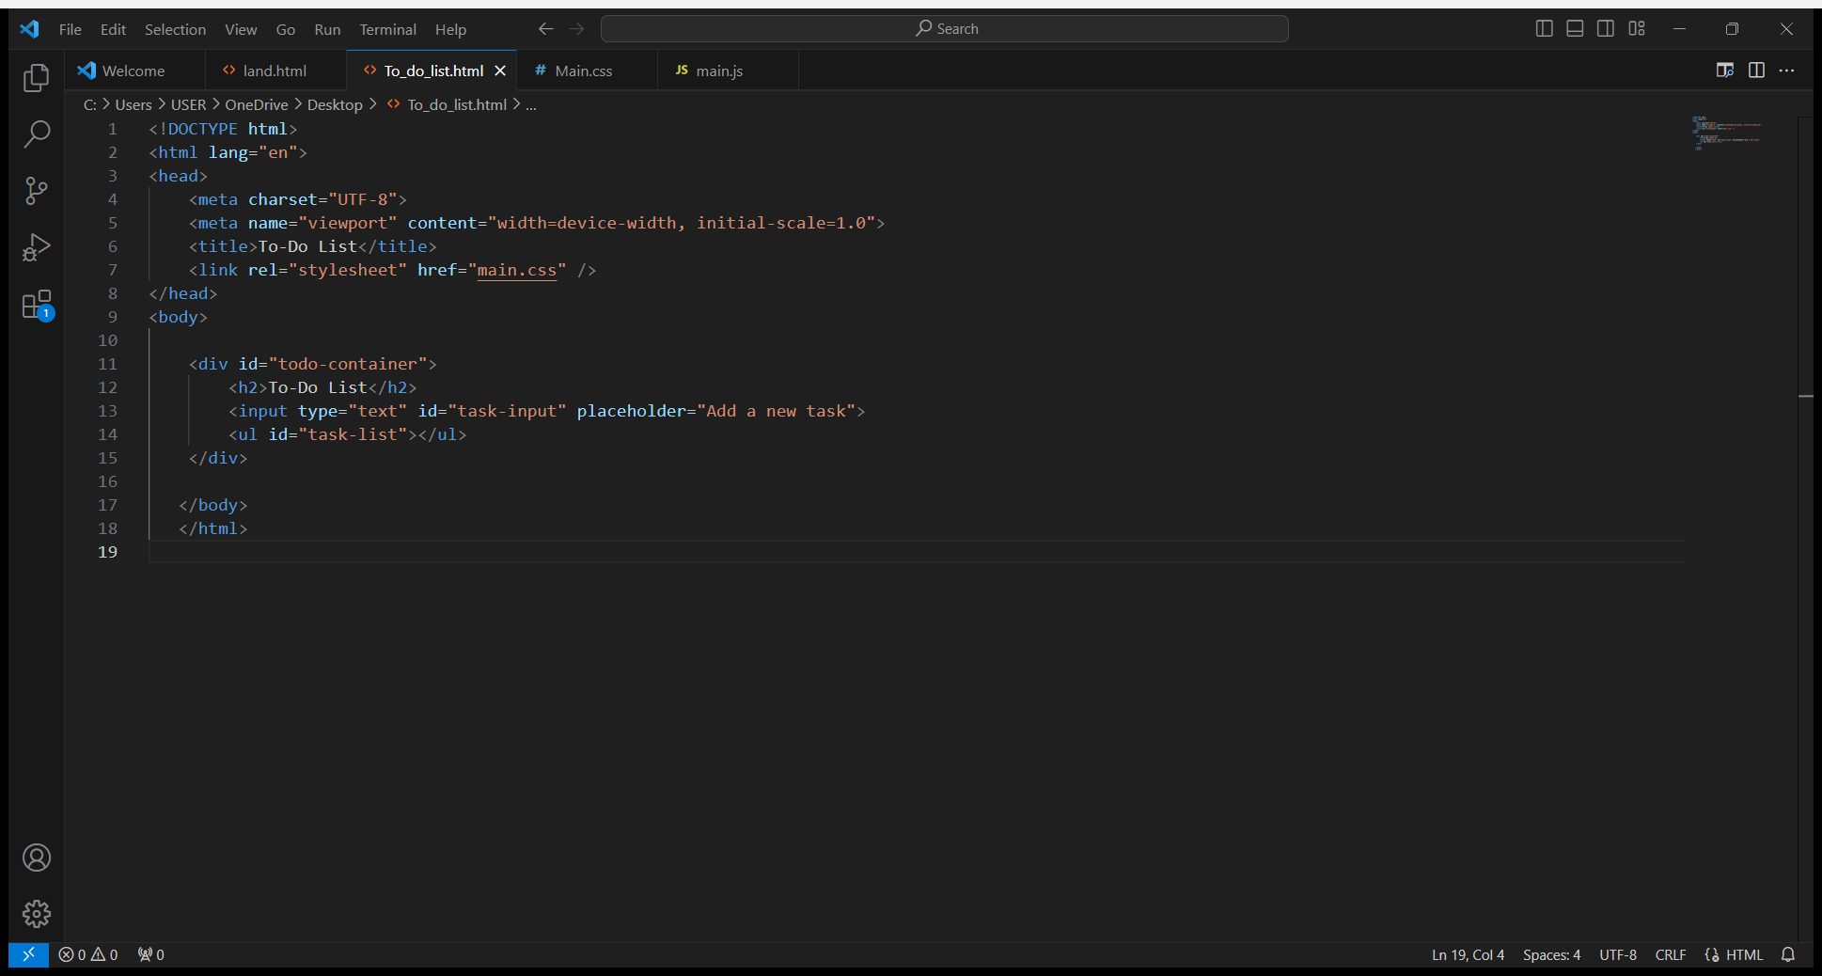**HTML CODE:**

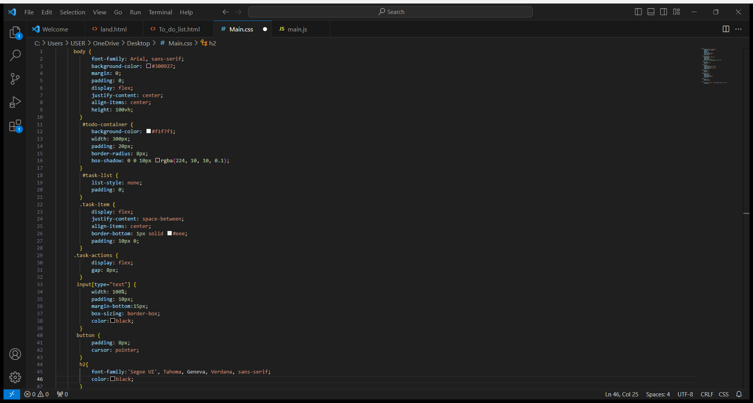**CSS CODE:**

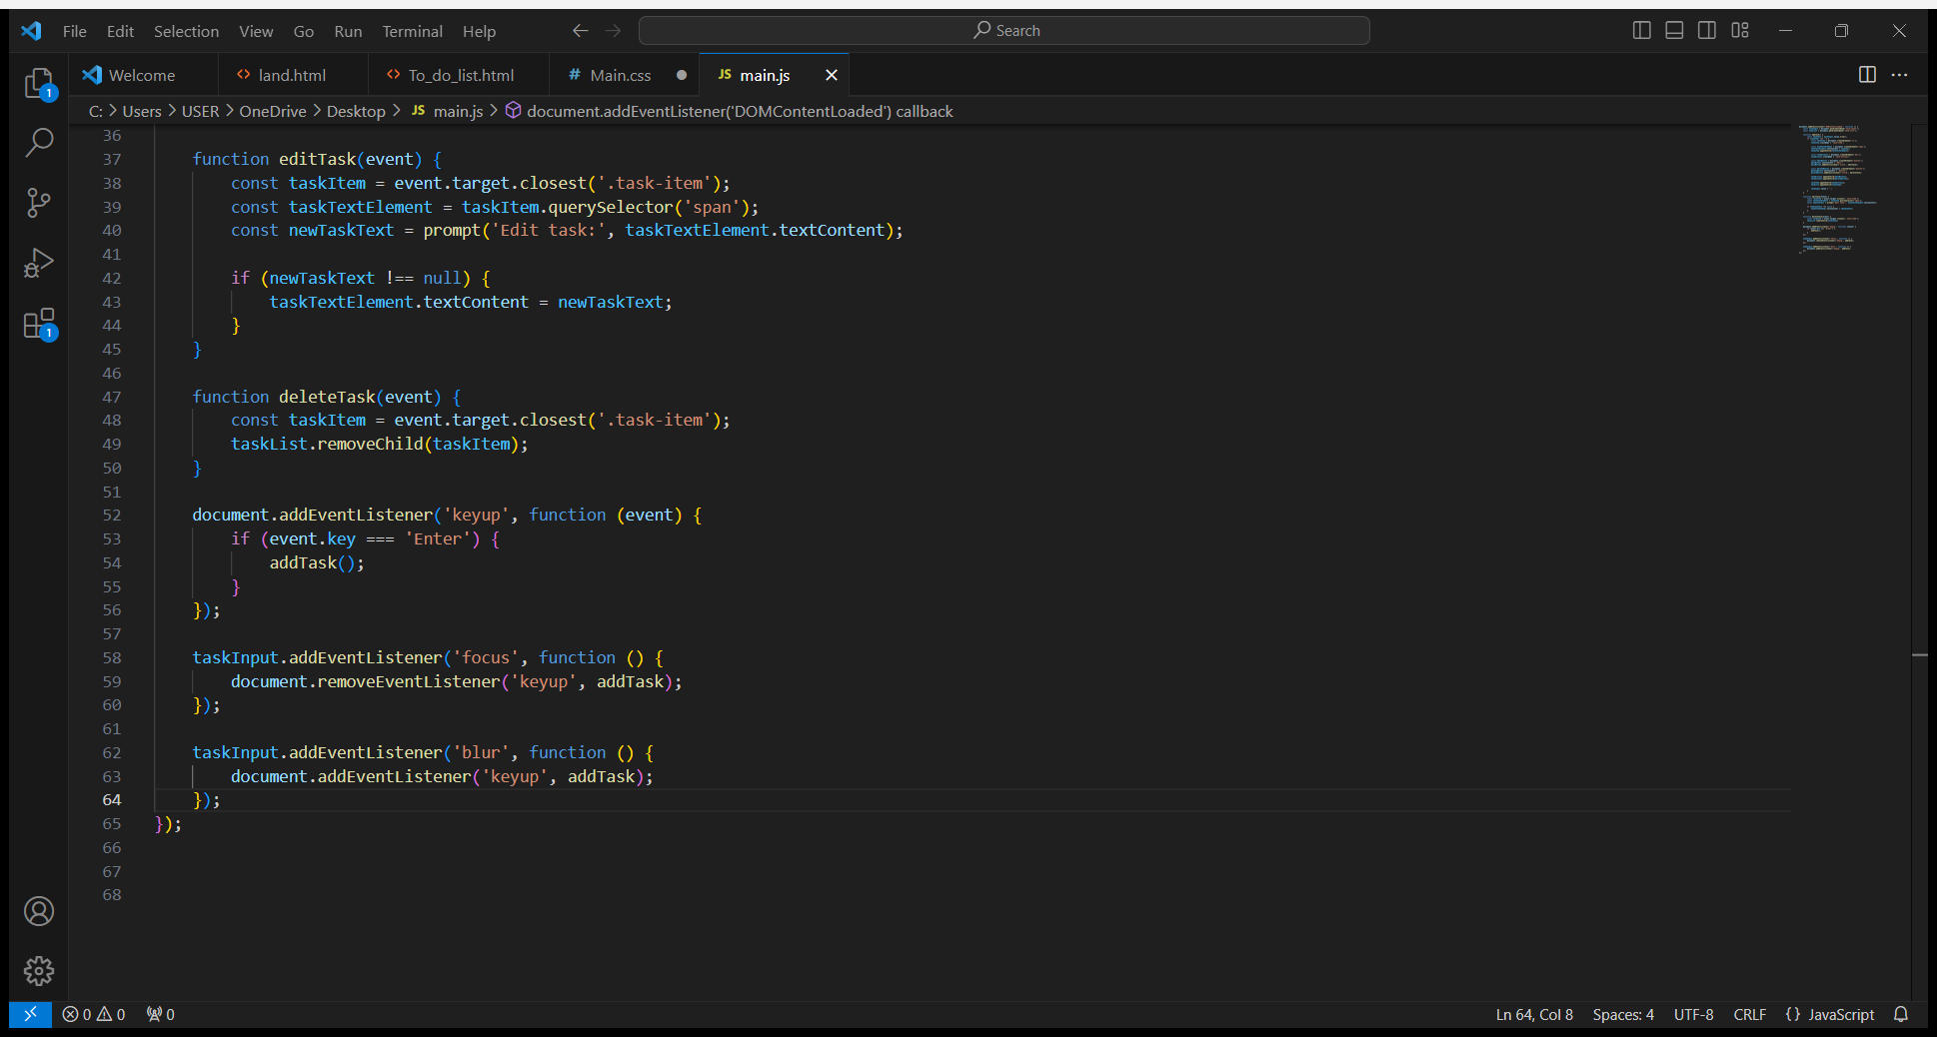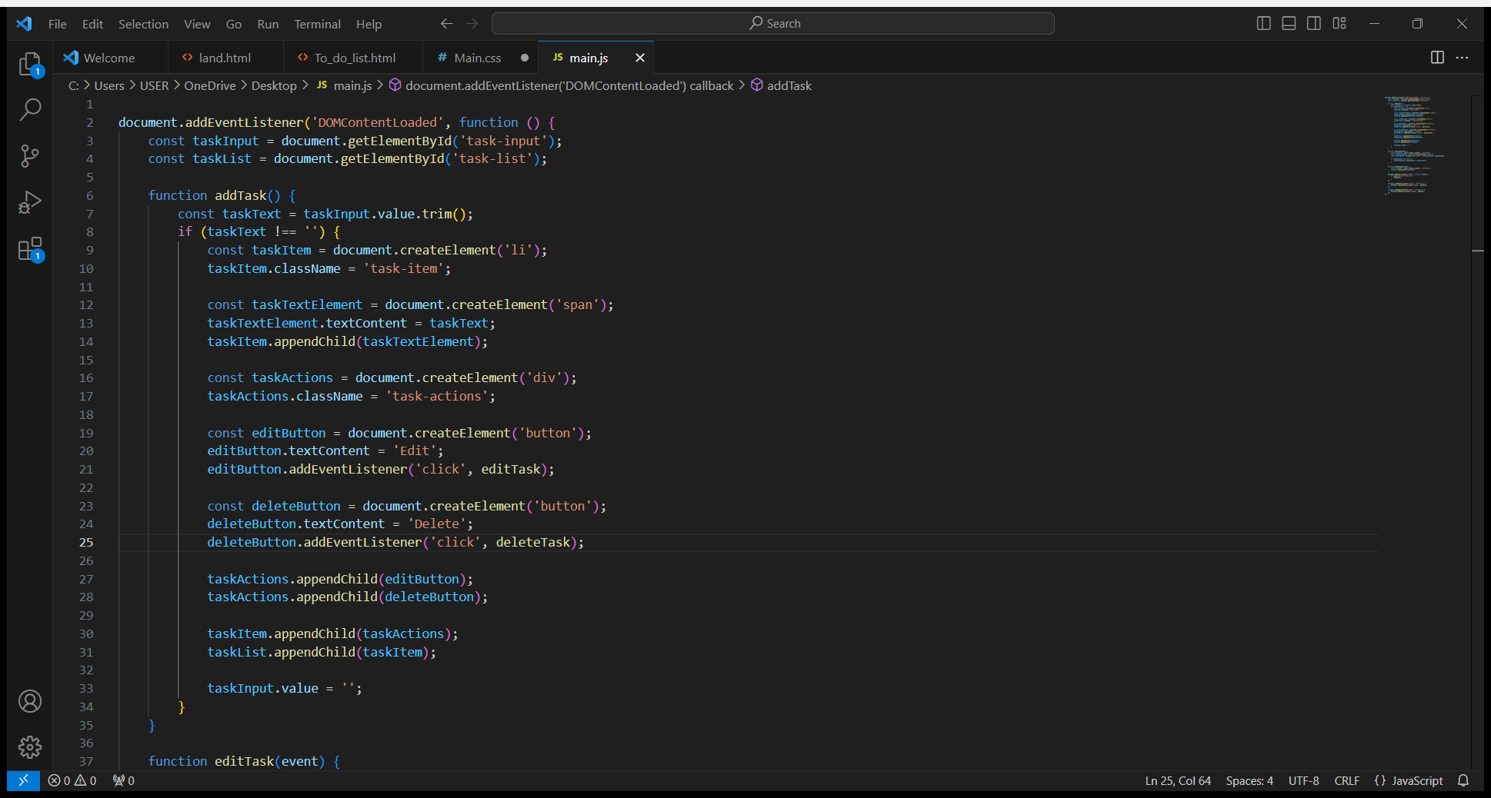**Javascipt Code:**

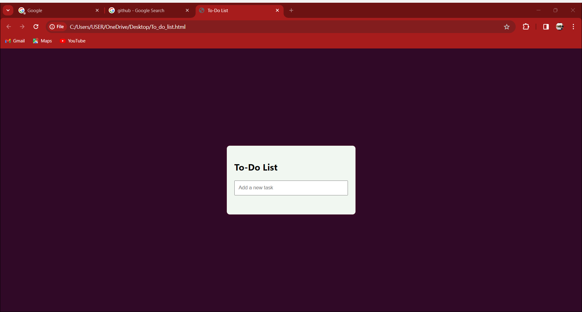**OutPut:**

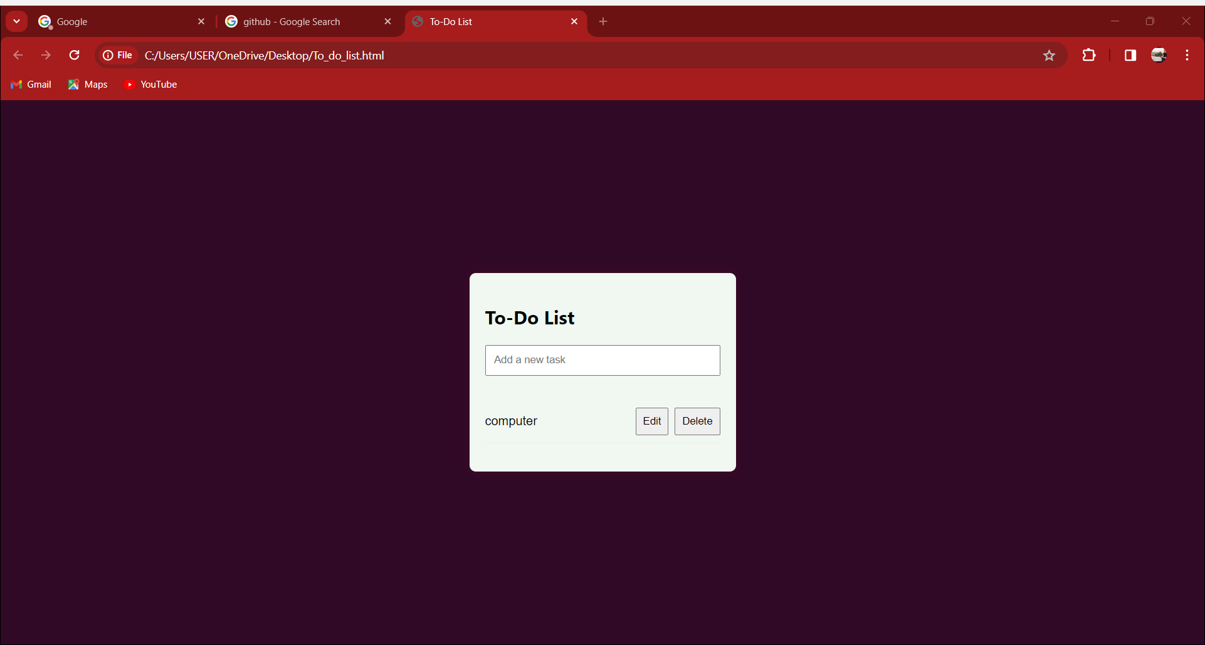

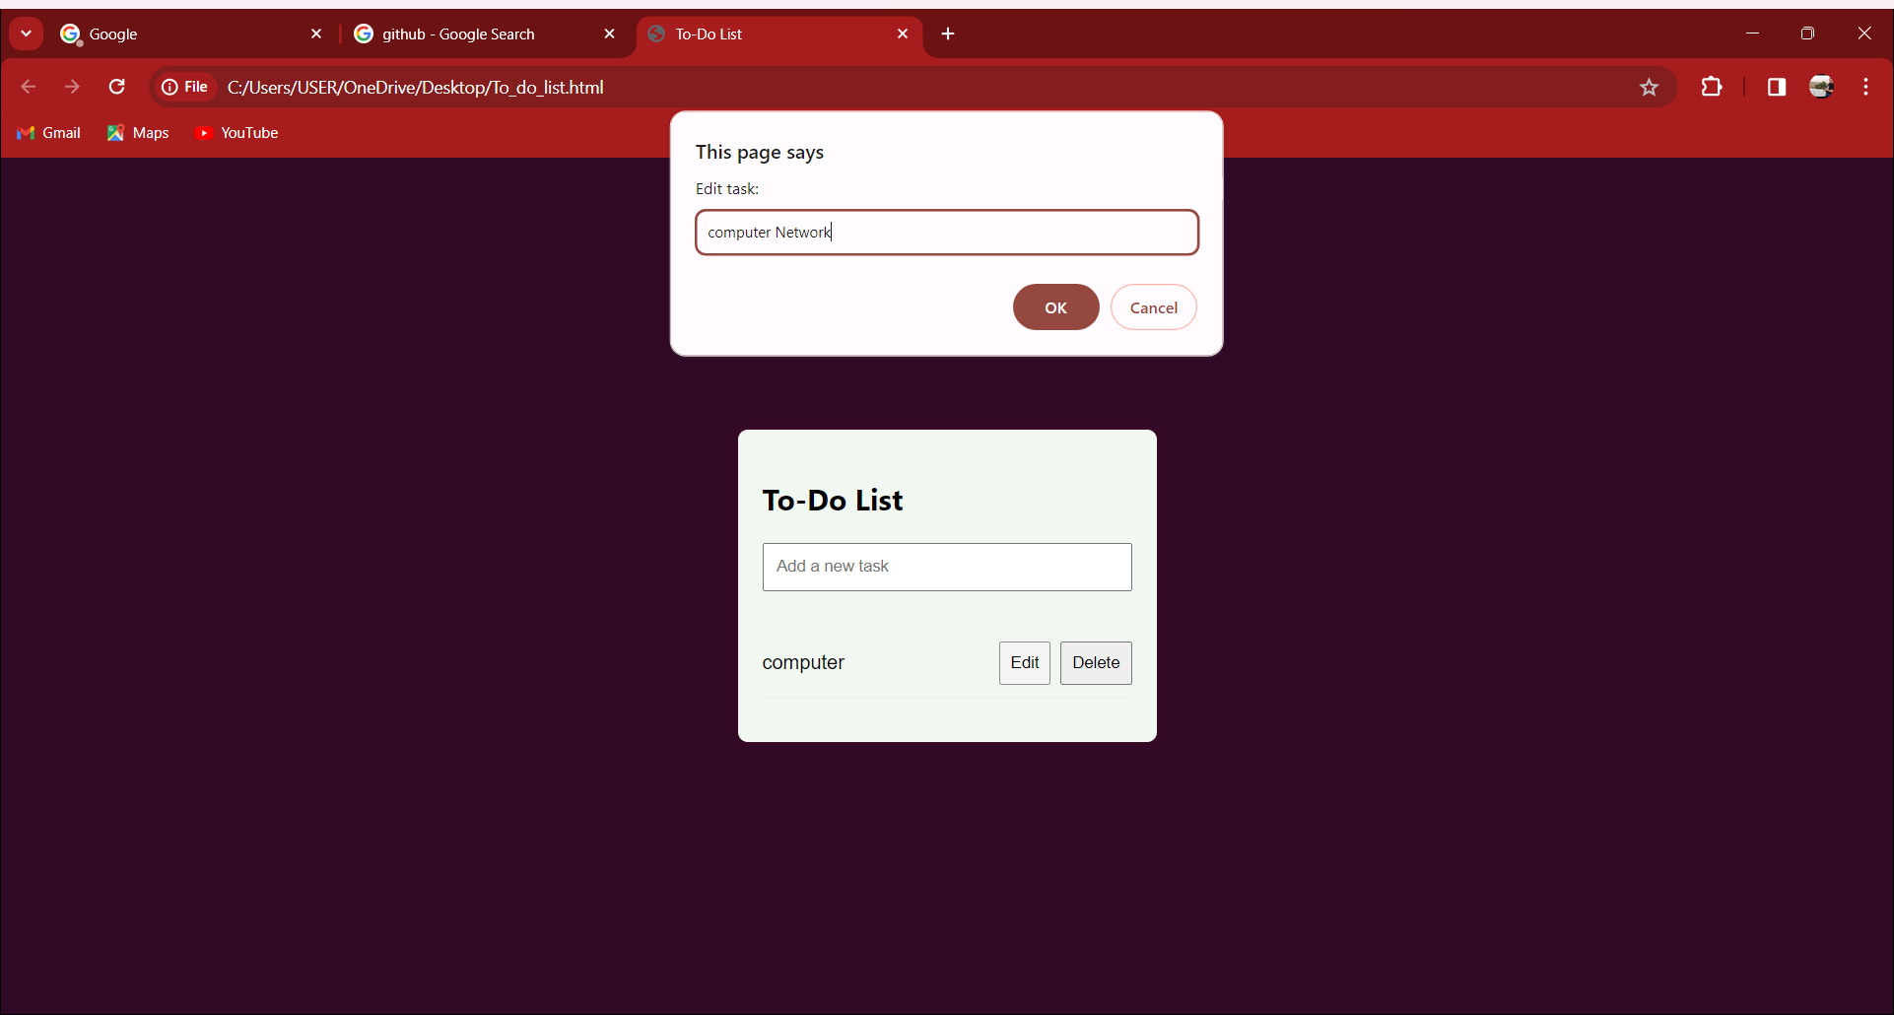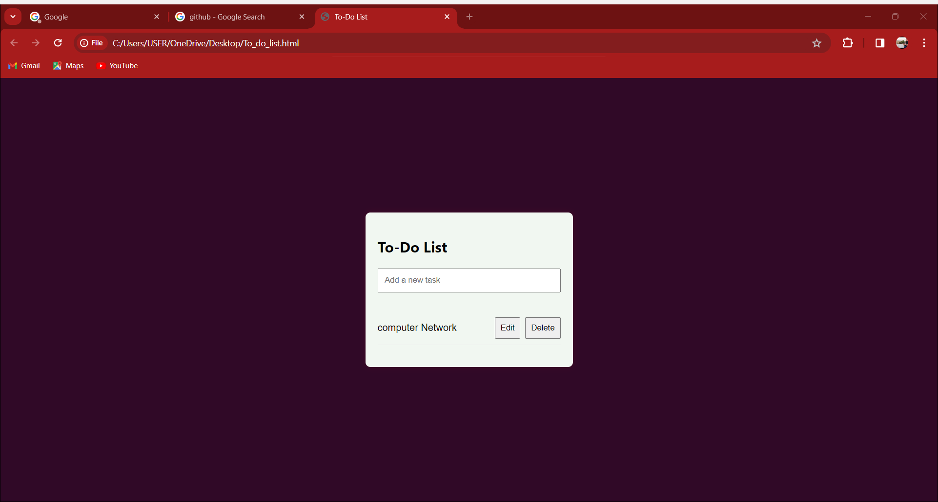

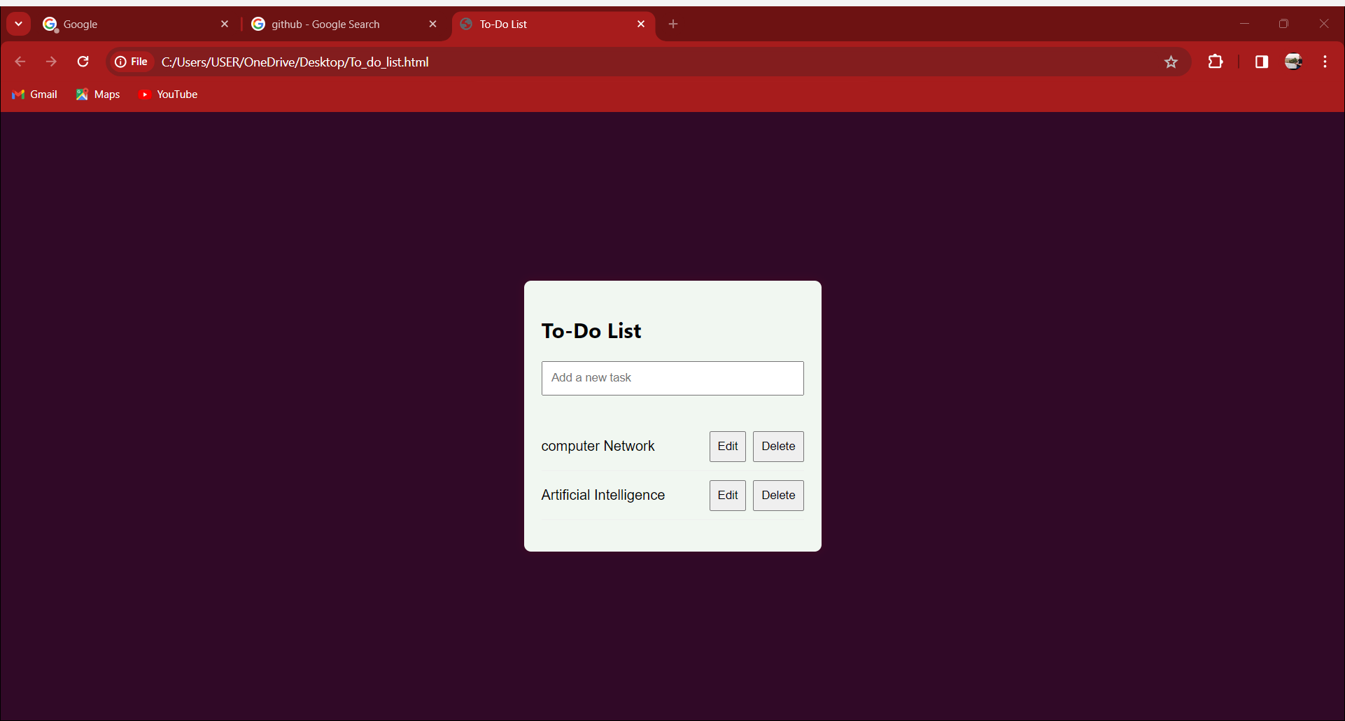

**Conclusion:**

The To-Do List Application successfully met its objectives by providing users with a straightforward and efficient tool for task management. The combination of HTML, CSS, and JavaScript allowed for a responsive, visually appealing, and functional user interface.